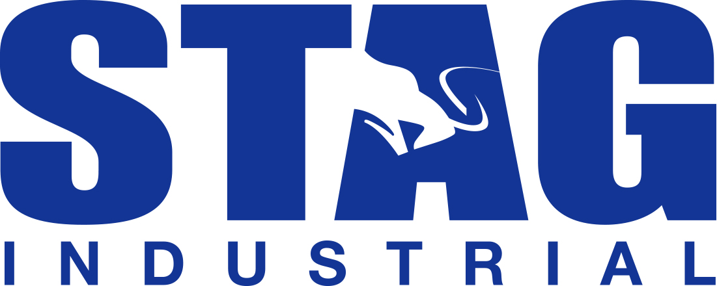

STAG INDUSTRIAL TO REPORT FIRST QUARTER 2019 RESULTS
APRIL 30, 2019

Boston, MA – April 3, 2019 - STAG Industrial, Inc. (the "Company") (NYSE:STAG) today announced that the Company will release its first quarter 2019 operating and financial results after market close on Tuesday, April 30, 2019. The Company will host its quarterly earnings conference call on Wednesday, May 1, 2019 at 10:00 a.m. Eastern Time.

The call can be accessed live over the phone toll-free by dialing (877) 407-4018, or for international callers, (201) 689-8471. A replay will be available shortly after the call and can be accessed by dialing (844) 512-2921, or for international callers, (412) 317-6671. The passcode for the replay is 13689330.

Interested parties also may listen to a simultaneous webcast of the conference call by visiting the Investor Relations section of the Company's website at www.stagindustrial.com, or by clicking on the following link:

http://ir.stagindustrial.com/CorporateProfile

About STAG Industrial, Inc.
STAG Industrial, Inc. is a real estate investment trust (REIT) focused on the acquisition and operation of single-tenant, industrial properties throughout the United States. The Company’s portfolio consists of 390 properties in 37 states with approximately 76.8 million rentable square feet as of December 31, 2018.
For additional information, please visit the Company’s website at www.stagindustrial.com.
Forward-Looking Statements
This press release, together with other statements and information publicly disseminated by the Company, contains certain forward-looking statements within the meaning of Section 27A of the Securities Act of 1933, as amended, and Section 21E of the Securities Exchange Act of 1934, as amended. The Company intends such forward-looking statements to be covered by the safe harbor provisions for forward-looking statements contained in the Private Securities Litigation Reform Act of 1995 and includes this statement for purposes of complying with these safe harbor provisions. Forward-looking statements, which are based on certain assumptions and describe the Company's future plans, strategies and expectations, are generally identifiable by use of the words "believe," "will," "expect," "intend," "anticipate," "estimate," "should," "project" or similar expressions. You should not rely on forward-looking statements since they involve known and unknown risks, uncertainties and other factors that are, in some cases, beyond the Company's control and which could materially affect actual results, performances or achievements. Factors that may cause actual results to differ materially from current expectations include, but are not limited to, the risk factors discussed in the Company's annual report on Form 10-K for the year ended December 31, 2018 as updated by the Company's quarterly reports on Form 10-Q. Accordingly, there is no assurance that the Company's expectations will be realized. Except as otherwise required by the federal securities laws, the Company disclaims any obligation or undertaking to publicly release any updates or revisions to any forward-looking statement contained herein (or elsewhere) to reflect any change in the Company's expectations with regard thereto or any change in events, conditions or circumstances on which any such statement is based.
Source: STAG Industrial, Inc.
Contact:
STAG Industrial, Inc.
Matts Pinard, Senior Vice President
617-226-4987
InvestorRelations@stagindustrial.com

